BeNutritious

Requirement Specification Document

**Submitted For:**

SER515 – Software Enterprise: Inception and Elaboration.

Arizona State University

**Submitted By:**

Akash Chugh

ASU ID: 1211165446

Email: Akash.Chugh@asu.edu

Table of Contents

Executive Summary 3

1.1 Project Overview 3

1.2 Purpose and Scope of this Specification 3

Product/Service Description 3

1.3 Product Context 3

1.4 User Characteristics 3

Assumptions 3

1.5 Constraints 3

1.6 Dependencies 4

Requirements 4

1.7 Functional Requirements 5

1.8 User Interface Requirements 5

1.9 Usability 7

1.10 Performance 7

1.11 Manageability/Maintainability 7

1.12 System Interface/Integration 8

1.13 Security 8

1.14 Data Management 8

1.15 Standards Compliance 9

1.16 Portability 9

User Scenarios/Use Cases 9

# Executive Summary

## Project Overview

An android application is to be developed which takes users’ information and displays calories needed, nutritions needed and also suggests meals based on the day’s meal consumptions. This document is intended for android developers, software engineers and project managers.

## Purpose and Scope of this Specification

The purpose of the document is to provide the reader a first hand knowledge of the requirements and clear any ambiguity.

In scope

This document addresses requirements related to the development of the project.

* Creation of an android Application that supports APK 21 and above.

Out of Scope

The following items are out of scope

* Support for android APK levels 20 and below.
* Portrait mode is not supported by the Application.

# Product/Service Description

In the modern world everybody needs information at their fingertips. The application provides nutritional data and suggests foods at the click of a button. It also displays the calories needed by the individual based on their age, gender and lifestyle.

## Product Context

The application does not have any dependencies. Though the application would contain a database that would be required but does not need to externally available to the application once developed.

## User Characteristics

Create general customer profiles for each type of user who will be using the product. Profiles should include:

* The user should understand his/her lifestyle and remember the age correctly.

## Assumptions

The project assumes the user should be able to devlelop and install an android Application.

## Constraints

* The android device should be APK level 21 and above.
* The device should have sufficient memory to install the application.

## Dependencies

List dependencies that affect the requirements. Examples:

N/A

# Requirements

* An android application needs to be developed in Android Studio 2.2 using the resources provided by Android Studio.
* The application should have the following flow.(Design is discussed in section 3.2 User Interface requirement)
* First the user should be presented with a screen that asks for the user’s name, age, gender and the lifestyle.
* The name, age should be edit text views and gender should be radio button with male, female option.
* The lifestyle should be a drop down menu with three options to chose from Sedentary, Moderately Active, and Active.
* If the user tries to choose a gender option before inputing the age a warning message to enter the age should be displayed.
* When the user inputs the age the validity should be checked. The age should be between 1 and 116.
* Once the user chooses the gender a further option should be displayed. The further option consist of two radio buttons Yes and No that are asked in conjunction with the question Are you pregnant ?. This further option should only be displayed if the user selects female as the gender and her age is between 26 and 32, else this option should be invisible.
* If the user does not choses a gender option and clicks on the next button a warning message is to be displayed to input the gender before continuing.
* Once the button is clicked validations for age and gender are to be done.
* Further the second screen should be displayed and the calories should be displayed.
* The value should not display at once, but increase from zero to the final value within a span of five seconds and a button should be displayed to move to the the next screen.
* When the user click this button the the third screen should start and the following operations should be performed.
* A complete details of the specific minerals requirements should be displayed.(The minerals are fetched from the database which is specified later in section 3.8
* Once the information is displayed the user should be presented with a button(make More Sense). On clicking the button the screen should be refreshed and the user should be given a choice of selecting the food category.
* Once the food category is selected, a second option should appear to select the sub category.(These options are also fetched from a database).
* The user should be made available a button(NutriToday) which when the user clicks a new screen appears.
* The new screen displays the exact minerals required by subtracting the user’s everyday nutrient requirement from the meals nutrients that he has had from the morning.
* Once the exact minerals are displayed the button (Food suggestions) is displayed and when the user clicks that button the next screen should appear
* The next screen should display the food that the user should have during the day. The food is based on the nutrients that the user requires as per the computation.(Based on the required nutrients food is fetched from the database).Describe all system requirements in enough detail for designers to design a system satisfying the requirements and testers to verify that the system satisfies requirements.

## Functional Requirements

| Req# | Requirement | Comments | Priority |
| --- | --- | --- | --- |
| 1 | The application should handle all the three cases of lifestyles. | Lifestyle = “Sedentary” or “Active” or “Moderately Active” | 1 |
| 2 | The pplication should be able to handle cases for pregnant and non pregnant users. | If gender == female and age >26 and age < 32 display the radio button to en quire about pregnancy. | 1 |
| 3 | The user should be provided with a list of options when the user starts typing the food category | The main food category should be fetched from the database and displayed in the drop down | 1 |
| 4 | The user should be provided with a list of options when the user starts typing the food sub category. | The sub food category should be fetched from the database and displayed in the drop down. The sub category fetched should be in accordance with the main food category selected. | 1 |

## User Interface Requirements

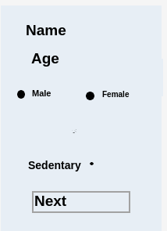The first screen should be as displayed.

The next screen should display the following. Then once the calories are displayed the following should appear

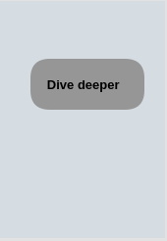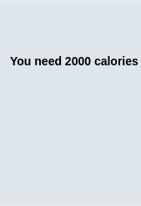

The next screen should display the minerals : Further the next screen should display the option to choose a food category and a sub category.

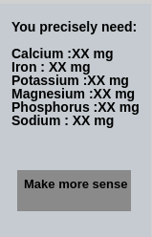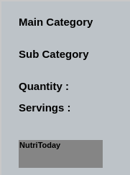

Next the required nutrients should be shown. The final screen would show the actual food suggestions.

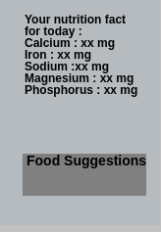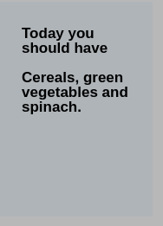

## Usability

Include any specific usability requirements, for example,

The user should be able to install an Android application and use the it.

## Performance

N/A

### Capacity

N/A

### Availability

N/A

### Latency

N/A

## Manageability/Maintainability

### Monitoring

N/A

### Maintenance

N/A

### Operations

Specify any normal and special operations required by the user, including:

* The user should be able to install an android application.
* The user should be able to identify the age and gender.

## System Interface/Integration

A database containing four tables are provided and needs to be added in the project. It is used to fetch various details as explained later I section 3.8.

### Network and Hardware Interfaces

N/A

### Systems Interfaces

N/A

## Security

### Protection

N/A

### Authorization and Authentication

N/A

## Data Management

A database is provided with four tables

The schema of all four have been provided.

Based on the _id(Age) gender and lifestyle the calorie information is fetched and displayed.

Table : food_calorie

|  |  |  |  |  |
| --- | --- | --- | --- | --- |
| Column name | _id | Calorie | Gender | lifestyle |
| Type | Numeric | Numeric | String | String |

Based on the _id(Age) gender(also whether pregnant) and lifestyle the minerals information is fetched and displayed.

Table : nutrientsChart

|  |  |  |  |  |  |  |  |  |  |  |  |
| --- | --- | --- | --- | --- | --- | --- | --- | --- | --- | --- | --- |
| Column Name | _id | Gender | Pregnant | Calcium | Iron | Magnesium | Sodium | Potassium | Phosphorus | Minerals | Values |
| Type | Numeric | String | String | Numeric | Numeric | Numeric | Numeric | Numeric | Numeric | String | String |

Based on the _id (food) the user selects the sub category has to be populated. Once the user selects the sub category the various minerals needed are fetched and are calculated using their daily requirements. Then the daily requirements are fetched.

Table: food_minerals

|  |  |  |  |  |  |  |  |  |  |  |  |
| --- | --- | --- | --- | --- | --- | --- | --- | --- | --- | --- | --- |
| Column Name | _id | Food | Serving | Weight | Kilo calorie | Calcium | Iron | Sodium | Potassium | Phosphorus | Protein |
| Type | String | String | String | Numeric | Numeric | Numeric | Numeric | Numeric | Numeric | Numeric | Numeric |

Once the requirements are calculated the lacking mineral is identified by identifying the largest deficit value. Once the mineral is identified it is passed to the field of Minerals column of nutrientsChart and the column values is fetched accordingly. The column values contains the food suggestions and is displayed.

## Standards Compliance

N/A

## Portability

If portability is a requirement, specify attributes of the system that relate to the ease of porting the system to other host machines and/or operating systems. For example,

* N/A

# User Scenarios/Use Cases

* A male user inputs the age, gender and lifestyle .Further he selects the meals and he is provided with food suggestions.
* A female non-pregnant user inputs the age, gender and lifestyle .Further he selects the meals and he is provided with food suggestions.
* A pregnant female user inputs the age, gender and lifestyle .Further he selects the meals and he is provided with food suggestions.